College of Arts and Sciences

Office of the Associate
and Assistant Deans

114 University Hall
230 North Oval Mall
Columbus, OH 43210

614-292-1667 Phone
asc.osu.edu

October 6, 2024

W. Randy Smith, Vice Provost
Council on Academic Affairs
Bricker Hall
CAMPUS

Dear Randy:

I am pleased to endorse the proposal by the College of Arts and Sciences to create a certificate in Civil Discourse for Citizenship, effective Autumn 2024. The Center for Ethics and Human Values will be responsible for overseeing the certificate. The certificate (Types 1b) is focused on current OSU students.

The proposed curriculum is well designed and addresses critical issues around political discourse, which has become increasingly important as political rhetoric becomes more divisive recently. It also aligns closely with the Listen, Learn, Discuss initiative, which the director of the center was involved in. The certificate should be of interest to students across the university. The certificate does not duplicate any other currently offered at Ohio State. It has the full support of the College of Arts and Sciences.

Sincerely,

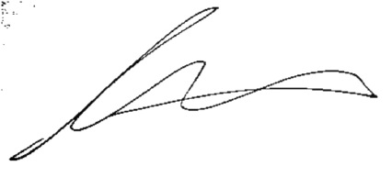

Andrew W. Martin
Associated Dean for Undergraduate Education
Professor, Department of Sociology

